**113年學力檢測測驗題本**

**英語文五年級**

作答注意事項：

各位同學：

你們好。

這是一份英語文的試題，總共35題。

第一個部份是15題聽力能力檢測，

第二個部份是20題閱讀能力檢測。

測驗時間為40分鐘。

每一題請選出**一個最合適的答案**，並用2B鉛筆在答案卡畫記，不可超出格線外，如果需要修改答案，請使用橡皮擦擦拭乾淨，再重新畫記。

畫記說明：

當你想選擇的答案為時，正確畫記為① ② ③ ●

其他事項：

* 每一題都要回答。
* 試題如有錯誤，請立即告知老師。

|  |  |
| --- | --- |
| 學 校 |  |
| 班　級 |  |
| 座　號 |  |
| 姓　名 |  |

**113年學力檢測題本**

**英語文五年級聽力及閱讀能力檢測**

各位同學，我們將要進行英語的聽力能力檢測和閱讀能力檢測。

第一部分是聽力能力檢測，

會先說明作答方式，請注意試題本上的例題，錄音說明完才會開始播放考試的題目。每題會播放兩遍，題目不在試題本上，請依照聽到的內容，並看到各題的四個選項中，選出一個正確或最佳的答案，並畫記在答案卡上。

錄音唸下一題時，你就要跟著做下一題。錄音會帶著你完成所有的聽力題目。

開始作答後，請自行完成測驗，監考老師不會回答任何問題。

但是如果你感覺身體不舒服，可以舉手向監考老師反應。

現在請翻頁。聽力能力檢測即將開始，請安靜並專心做答。

**第一部分：聽力能力檢測，共二大題，15小題。**

**第一大題：聽辨字音、辭彙和句子**

**【說明】**

**請依據所聽到的辭彙、句子和敘述，選出最適當或相關的答案與回應，將答案的號碼塗在答案卡上，每一題會重複唸兩次，共8小題。**

**【例題】**

**聽到單字：rabbits, rabbits**

**看到選項：① snakes ② dogs ③ cats ④ rabbits**

**選出正確答案：④**

**現在請開始作答。**

|  |  |  |  |  |
| --- | --- | --- | --- | --- |
| **1.** | ① pill | ② Phil | ③ hill | ④ wheel |
| **2.** | ① bait | ② bake | ③ bad | ④ date |
| **3.** | ① nine | ② nineteen | ③ ninety | ④ night |

|  |  |  |  |  |
| --- | --- | --- | --- | --- |
| **4.** | ① | ② | ③ | ④ |
|  | 5A-Q4-1 | C:\Users\USER\AppData\Local\Microsoft\Windows\INetCache\Content.Word\5A-Q4-2.png | 5A-Q4-3 | 5A-Q4-4 |

|  |  |  |  |
| --- | --- | --- | --- |
| **5.** | ① Two hundred and fifteen | ② Two hundred and twenty-five | |
|  | ③ Two hundred and fifty-five | ④ Three hundred and fifty-five | |
| **6.** | ① | | ② | |
|  | C:\Users\USER\AppData\Local\Microsoft\Windows\INetCache\Content.Word\5A-Q6-1.png | |  | |
|  | ③ | | ④ | |
|  |  | |  | |

|  |  |  |
| --- | --- | --- |
| **7.** | ① | ② |
|  | 5A-Q7-1 |  |
|  | ③ | ④ |
|  | C:\Users\USER\AppData\Local\Microsoft\Windows\INetCache\Content.Word\5A-Q7-3.png |  |
| **8.** | ① | ② |
|  | 5A-Q11-1 | C:\Users\USER\AppData\Local\Microsoft\Windows\INetCache\Content.Word\5A-Q11-2.png |
|  | ③ | ④ |
|  | 5A-Q11-3 | 5A-Q11-4 |

**第二大題：生活辭句回應**

**【說明】**

**請依據所聽到的句子或問句，選出最適當的回應，並將答案的號碼塗在答案卡上，每一題會重複唸兩次，共7小題。**

**9.**

1. Amy, are you okay?
2. Amy, what time is it?
3. You are welcome, Amy.
4. Thank you very much, Amy.

**10.**

| September 10th | | | | |
| --- | --- | --- | --- | --- |
| Time | 7:30 AM | 4:00 PM | 6:00 PM | 9:00 PM |
| Things to Do | **Go to school** | **Go home** | **Have dinner** | **Go to bed** |

1. It’s six o’clock.
2. It’s seven thirty.
3. It’s nine o’clock.
4. Yes, he is.

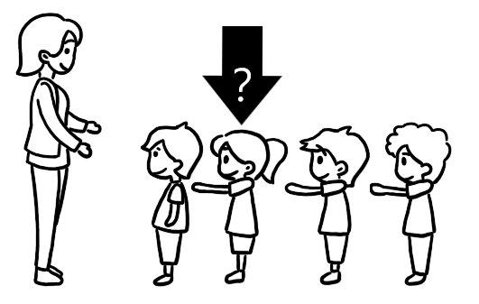

**11.**

1. She is Judy.
2. She is nine.
3. She is next to Andy.
4. She is the teacher.

**12.**

1. He’s in the living room.
2. He’s in the kitchen.
3. He’s in the car.
4. He’s in the library.

|  |  |  |
| --- | --- | --- |
| **13.** | ① | ② |
|  | Shopping List  □Oranges  □Grapes  □Guavas | Shopping List  □Oranges  □Apples  □Lemons |
|  | ③ | ④ |
|  | Shopping List  □Oranges  □Apples  □Bananas | Shopping List  □Papayas  □Grapes  □Bananas |

**◆14-15**

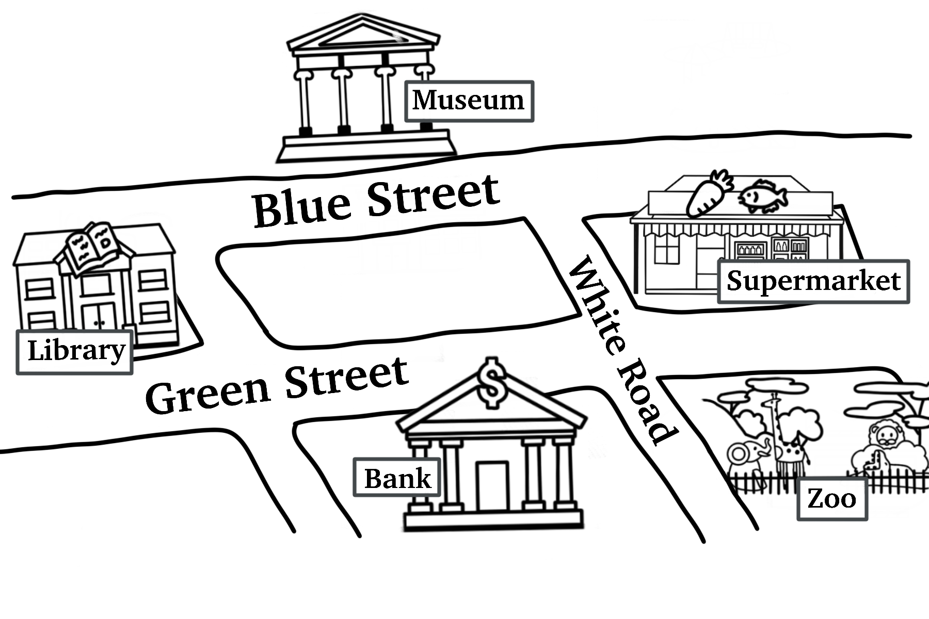

**14.**

1. They are at Taipei Library.
2. They are at Taiwan Museum.
3. They are at Taipei Zoo.
4. They are at Mega Bank.

**15.**

1. She is going to Red Road.
2. She is going to Welcome Supermarket.
3. She is going to Taiwan Museum.
4. Bob is going to Taipei Library.

**各位同學，聽力能力檢測已經完成了，下一大題開始為閱讀能力檢測。**

**現在請翻到下一頁繼續完成作答。**

**第二部分：閱讀能力檢測**

**【說明】**

**請依單字或圖片選出相對應的答案，並將其號碼塗在答案卡上，共20小題。**

**【例題】**

**看到題目：**

**看到選項：**

**① read ② write ③ dance ④ sing**

**選出正確答案：①**

**現在請開始作答。**

**16. kitchen**

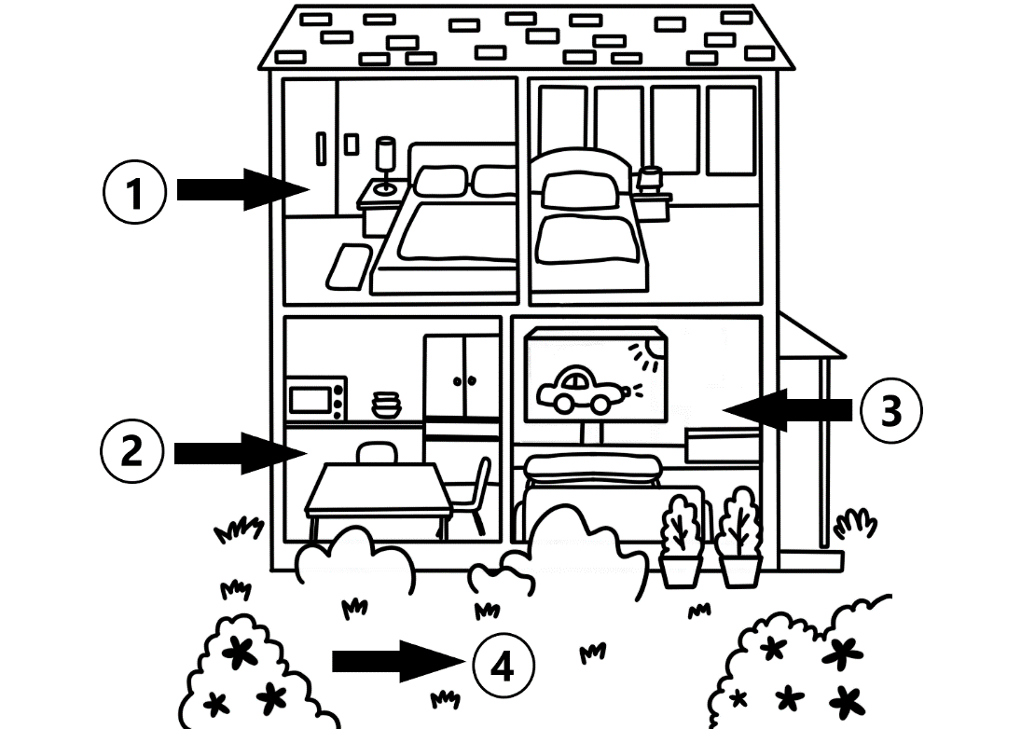

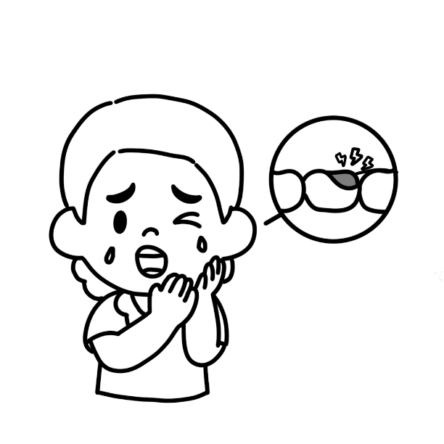**17.**

1. cold
2. stomachache
3. headache
4. toothache



**18.**

1. a beautiful dress
2. a beautiful scarf
3. a nice jacket
4. a nice vest

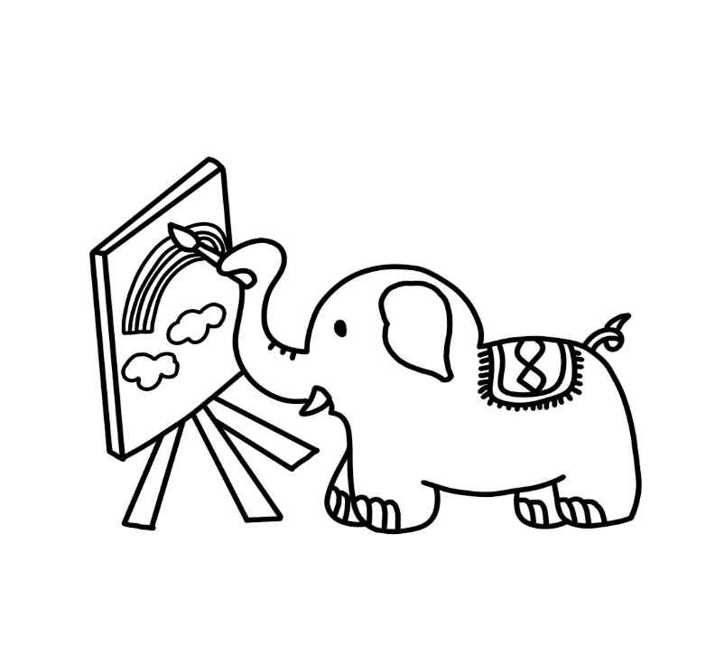**19.**

1. The bird can sing.
2. The lion can dance.
3. The elephant can draw.
4. The bear can ride a bike.

**20. There are ______.**

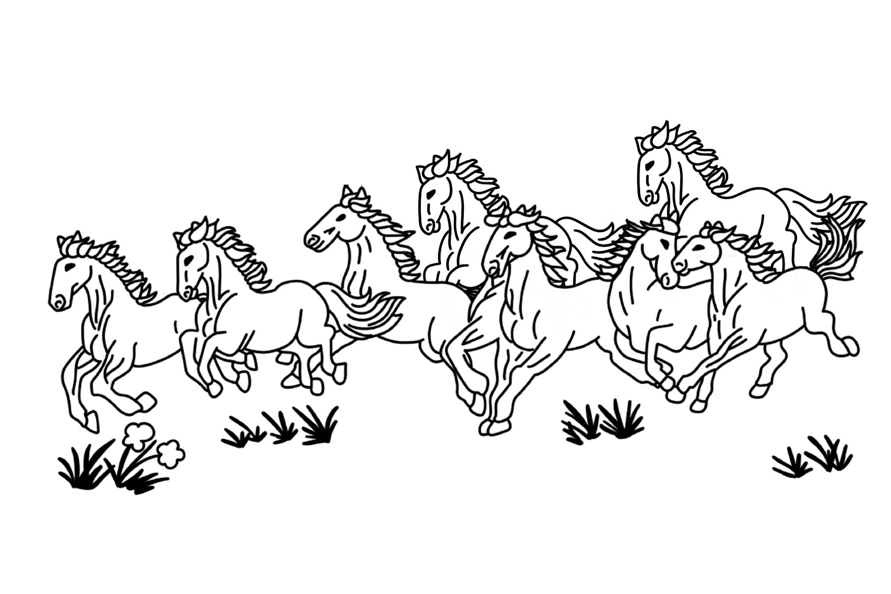

1. a horse
2. eighty turtles
3. eighteen zebras
4. eight horses

**21. Wash your hands**.

|  |  |  |
| --- | --- | --- |
|  | ① | ② |
|  | C:\Users\USER\AppData\Local\Microsoft\Windows\INetCache\Content.Word\5B-Q18-1.png | 5B-Q18-2 |
|  | ③ | ④ |
|  |  | 5B-Q18-4 |

**22. Circle the word “cat”.**

|  |  |  |
| --- | --- | --- |
|  | ① | ② |
|  | 5B-Q20-1 | 5B-Q20-2 |
|  | ③ | ④ |
|  | 5B-Q20-3 | C:\Users\USER\AppData\Local\Microsoft\Windows\INetCache\Content.Word\1.png |

**23.** **This is Will’s weekly plan. Which is true?**

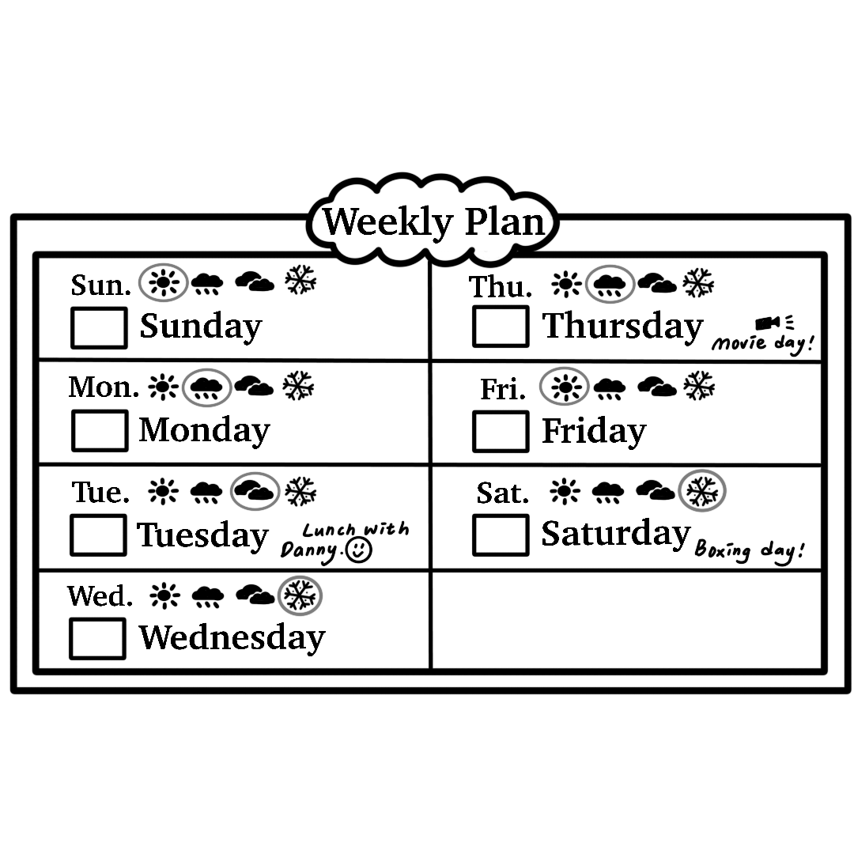

1. It’s cloudy on Monday.
2. It’s sunny on Friday.
3. It’s hot on Wednesday.
4. It’s rainy on Saturday.

**24.** **Jane was born(出生) in 2017. It’s 2024 now. How old is Jane?**

1. She is seventeen years old.
2. She is eleven years old.
3. She is seven years old.
4. She is five years old.

**25.** **Jay’s friends show their feelings for his post (貼文). Which is true?**

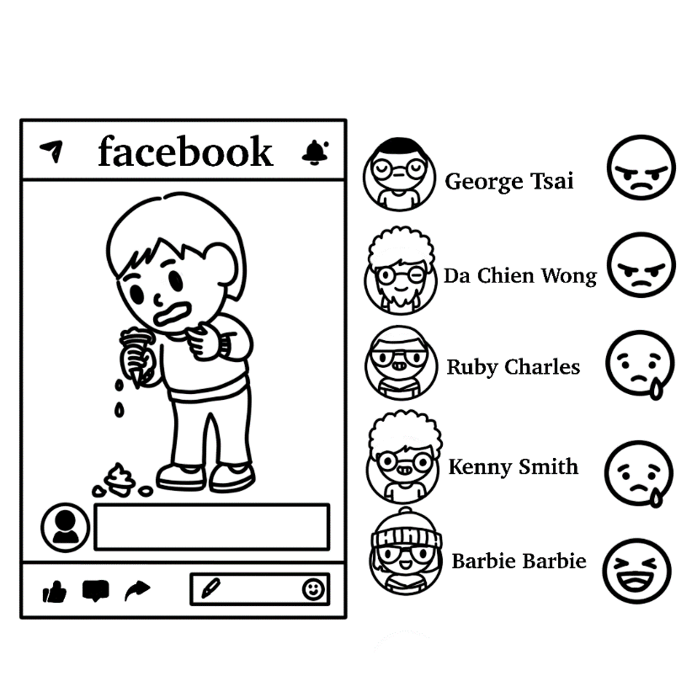

1. George is happy.
2. Three of Jay’s friends are angry.
3. Two of Jay’s friends are happy.
4. Ruby is sad.

**26. Which is true?**

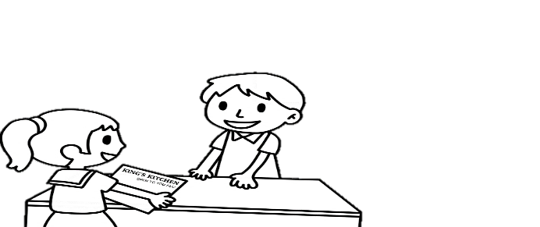

1. The hamburger is forty dollars.
2. The hot dog is forty-five dollars.
3. The girl wants some milk and juice.
4. The girl wants a hot dog, some noodles and some juice.

**27. The cook is short and heavy.**

|  |  |  |
| --- | --- | --- |
|  | ① | ② |
|  |  |  |
|  | ③ | ④ |
|  | C:\Users\USER\AppData\Local\Microsoft\Windows\INetCache\Content.Word\5A-Q27-3.png | 5A-Q27-4 |

**28. Hank doesn’t have a pencil.**

**He says: “Lily, may I borrow your pencil?”**

|  |  |  |
| --- | --- | --- |
|  | ① | ② |
|  | C:\Users\USER\AppData\Local\Microsoft\Windows\INetCache\Content.Word\5A-Q28-1.png | C:\Users\USER\AppData\Local\Microsoft\Windows\INetCache\Content.Word\5A-Q28-2.png |
|  | ③ | ④ |
|  | 5A-Q28-3 | C:\Users\USER\AppData\Local\Microsoft\Windows\INetCache\Content.Word\5A-Q28-4.png |

**29.**

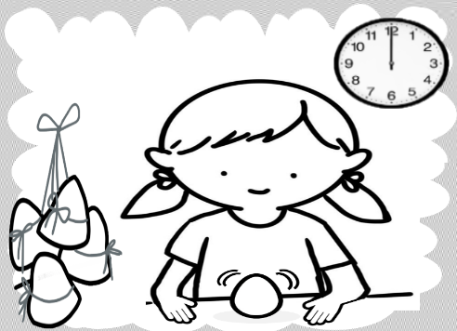

1. We get lucky money on Chinese New Year’s Eve.
2. We paint pomelo hats on Moon Festival.
3. We sing Christmas songs on Christmas.
4. We stand eggs on Dragon Boat Festival.

**30.**

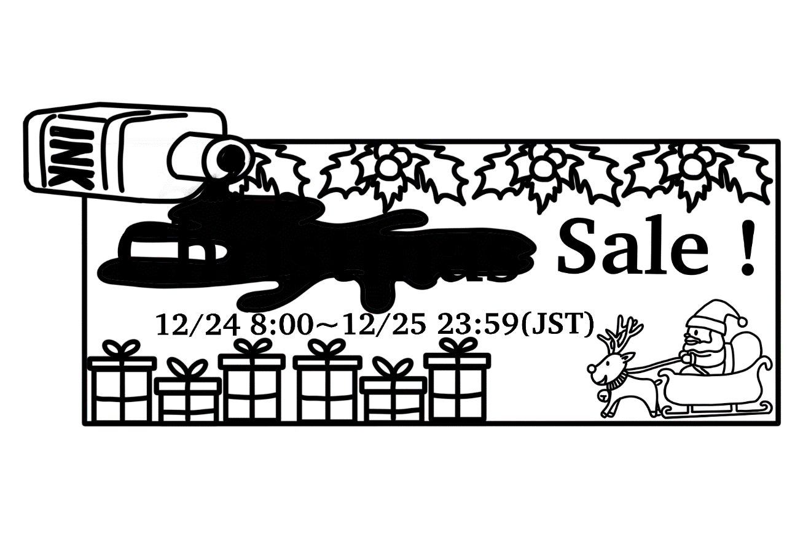

1. Christmas
2. Easter
3. Halloween
4. New Year

◆**31-32**

|  |  |
| --- | --- |
| **Student Emergency Contact Card (緊急連絡卡)** | |
| **Name:** Harry Yang | **School Name:** Sunny Elementary School |
| **Birthday:** 2012.6.19 | **Class:** 6-A |
| **Phone Number:** 0934-567890 | **Teacher:** Sharon Pong |
| **Contact (聯絡人) 1:** | **Contact 2:** |
| **Name:** Mandy Lin | **Name:** Nick Yang |
| **Birthday:** 1985.10.04 | **Birthday:** 2002.3.30 |
| **Phone Number:** 0912-345678 | **Phone Number:** 0987-654321 |
| **Relation:** Harry’s mother | **Relation:** Harry’s brother |
| **Job:** Doctor | **Job:** Police Officer |
| **5B-Q29-題目** | |

**31.** **Teacher Sharon has to call Harry’s mother. The number is _______.**

1. 0934-567890
2. 0912-345678
3. 0987-654321
4. 1985-1004

**32.** **Which is true?**

1. Nick is eleven years old.
2. Harry is a student.
3. Sharon is a doctor.
4. Mandy is Nick’s sister.

**◆33-35**

**Welcome to the Art Museum. This is our ticket price list (票價表).**

|  |
| --- |
|  |

**33. Windy goes to the Art Museum, but it’s not open. What day is it?**

1. It’s Sunday.
2. It’s Monday.
3. It’s Tuesday.
4. It’s Wednesday.

**34. Jerry is 9 years old. Jerry’s mom is 40 years old.**

**They go to the Art Museum.**

**Their tickets are one hundred and fifty dollars.**

**What day is it?**

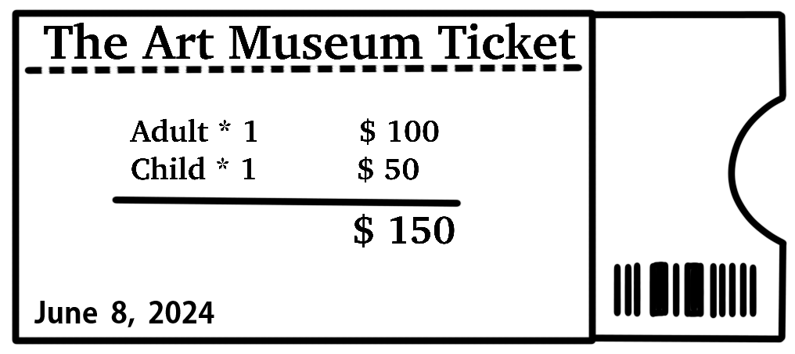

1. It’s Wednesday.
2. It’s Thursday.
3. It’s Friday.
4. It’s Saturday.

**35. What can we do in the museum?**

1. We can eat hamburgers.
2. We can drink soda.
3. We can walk the dog.
4. We can see paintings.