Examples for 2011 English Composition/Writing Contest

for Elementary School Students (國小國外組寫作比賽)
- Picture Writing看圖寫作 (100%) Please write a short story for each picture. You need to use the words in the word bank for each picture. 40-50 words for each picture.

- 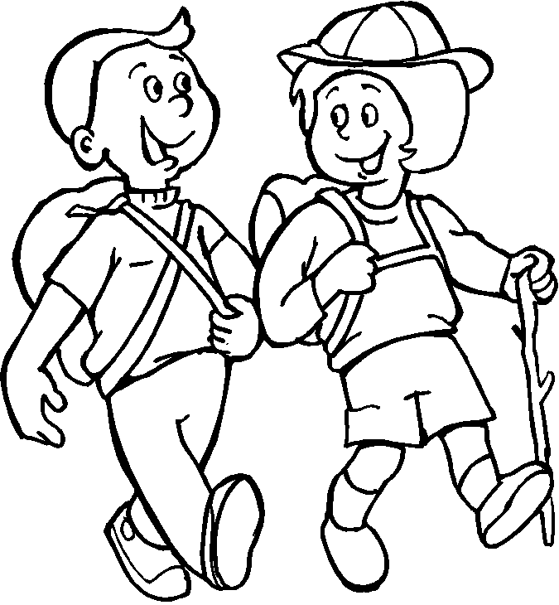 | mountain climbing | strong
- 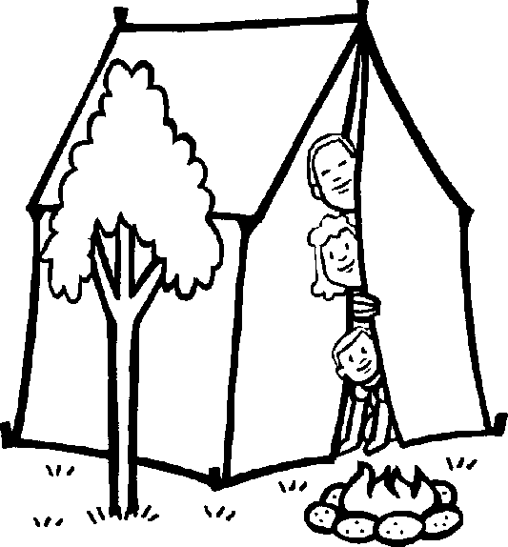 | camp fire | summer night

- 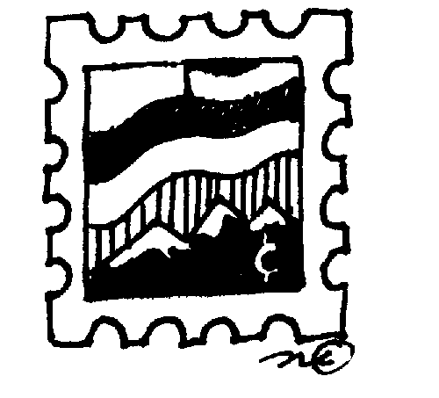 | stamp collecting | first letter
Example Answers for Picture Writing: Answers will vary.

