反思與創新～幼教師資培育
學術研討會

檢視我國師資培育發展，自1994年師資培育法施行以來，已逾20年，在師資培育多元化政策下，整個師資培育結構亦有大幅的調整，幼托整合後，幼兒教育師資培育再次有了新的變革，值此新的挑戰，如何兼顧與汲取過去幼教師資培育的優點並展望未來培育優秀的幼兒園師資，借鏡他國經驗，希冀找尋精進幼教師資培育的創新思考與方法。
本次研討會邀請美國與蘇格蘭幼教師資培育研究學者及國內相關研究發表者，透過分享、討論與對話，進行深度與廣度的探討，對未來臺灣幼教師資培育的發展提供反思與創新的互動激盪。

活動日期：2015年12月16日（三）至12月17日（四）
活動地點：臺北市立大學公誠樓2樓第3會議室及公誠樓4樓402教室（臺北市愛國西路1號）
主辦單位：臺北市立大學幼兒教育學系
研討會網路報名：請上 http://web.utaipei.edu.tw/~kid/ 或 http://goo.gl/xsmKCU
研習時數：核實發給，全程參與者給予全國教師在職進修資訊網13.5小時

活動議程：

 | 2015年12月16日（三）
08:30-08:50 | 報到
08:50-09:00 | 開幕式  郭淑芳副司長（教育部師資培育及藝術教育司）  吳清基總校長（臺灣教育大學系統）  戴遐齡校長（臺北市立大學）  趙家琛院長（臺北市立大學教育學院）  林佩蓉主任（臺北市立大學幼兒教育學系）
09:00-10:30 | 專題演講  主題：Conforming to Reform: Teaching Children in Neoliberal Early Education Systems  演講者：Christopher P. Brown  （美國德州大學奧斯汀校區課程與教學系副教授—專長幼兒教育）  *提供翻譯
10:30~10:40 | 休息
10:40~12:10 | 專題演講  主題：Working with Practicing Teachers in a High-Stakes Teaching Context to Rethink their Pedagogical Practices with Children of Diverse Backgrounds  演講者：Christopher P. Brown  （美國德州大學奧斯汀校區課程與教學系副教授—專長幼兒教育）  *提供翻譯
12:10-13:10 | 用餐（參加學員請自理）
13:00-14:30 | 專題演講  主題：幼兒園師資證照之研擬  演講者：林佩蓉  （臺北市立大學幼兒教育學系副教授系主任）
14:30-14:40 | 休息
14:40~16:30 | 座談會：當前幼教師資培育的反思與前瞻>  引言人  主題：社會變遷下幼教師應具備的能力  報告人：練雅婷（臺北市新生國小附設幼兒園園主任）  主題：蒙特梭利幼教師資的養成  報告人：陳又旭、吳依靜、劉莙莙、蔡珠玲（政治大學幼教所研究生）  主題：華德福幼教師資的養成  報告人：沈奕君、游依靜、陳苡佩、江佩穎（政治大學幼教所研究生）

 | 2015年12月17日（四）
08:40-09:00 | 報到
09:00-10:30 | 主題：INITIAL TEACHER EDUCATION IN SCOTLAND  演講者：John Eric Wilkinson  （蘇格蘭格拉斯哥大學退休榮譽教授/臺北市立大學講座教授-專長幼兒教育）  *提供翻譯
10:30~10:40 | 休息
10:40~12:10 | 主題：INITIAL TEACHER EDUCATION IN SCOTLAND  演講者：John Eric Wilkinson  （蘇格蘭格拉斯哥大學退休榮譽教授/臺北市立大學講座教授-專長幼兒教育）  *提供翻譯
12:10-13:10 | 用餐（參加學員請自理）
13:10-16:00 | 工作坊（地點：公誠樓4樓402教室，參加人數30人）  主題：Rethinking DAP to Meet the Needs of Children within Standardized Teaching Contexts  演講者：Christopher P. Brown  （美國德州大學奧斯汀校區課程與教學系副教授—專長幼兒教育）  *提供翻譯
16:00~16:10 | 休息
16:10-17:00 | 綜合討論（地點：公誠樓4樓402教室，參加人數30人）  主持人：林佩蓉  （臺北市立大學幼兒教育學系副教授系主任）  與談人：  Christopher P. Brown  （美國德州大學奧斯汀校區課程與教學系副教授—專長幼兒教育）

 | Christopher P. Brown  Associate Professor; Program Coordinator and Graduate Advisor for Early Childhood Education; Graduate Studies Committee Chair
Email cpbrown@utexas.edu
Courses of Instruction
Undergraduate:
Teaching Young Children
Early Childhood Program Development
Graduate:
Social Contexts of Early Childhood Education
Early Childhood Education Programs
Critical Perspectives in Early Childhood Education
Case Study Research
Curriculum theories for pre-kindergarten and kindergarten
Introduction to Systems of Human Inquiry
Mailing Address
The University of Texas at Austin
Curriculum & Instruction
1 University Station
Austin, TX 78712-0379
UT Mail Code: D5700

Profile
Christopher is an Associate Professor of Curriculum and Instruction in Early Childhood Education and a Fellow in Priscilla Pond Flawn Regents Professorship in Early Childhood Education. He currently serves as the Program Coordinator and Graduate Advisor for the Early Childhood Education Program Area. He is also the Chair for the Early Education/Child Development Special Interest Group of the American Educational Research Association.
His research centers on early childhood education stakeholders across a range of political and educational contexts respond to policymakers’ high-stakes standards-based accountability reforms. His recent work focuses on understanding how practicing and pre-service early childhood educators in high-stakes public teaching contexts can engage in practices that support the cultural, individual, and developmental learning needs of children. He has looked at this issue across a range of political and educational contexts using multiple theoretical and practitioner-based perspectives that span the fields of early childhood education, curriculum and instruction, teacher education, and policy analysis.
Such work has led to empirical, theoretical, and practitioner-oriented publications on such topics as: high-stakes standards-based accountability reform in early childhood, early learning standards, pre-kindergarten (Pre-k) assessment, Pre-k alignment with elementary school, school readiness, culturally relevant and developmentally appropriate teaching, kindergarten within a standardized education system, neoliberal reform, teacher education, professional development, and teaching a mandated curriculum.
完整資訊請見 http://www.edb.utexas.edu/education/departments/ci/about/faculty/5318/

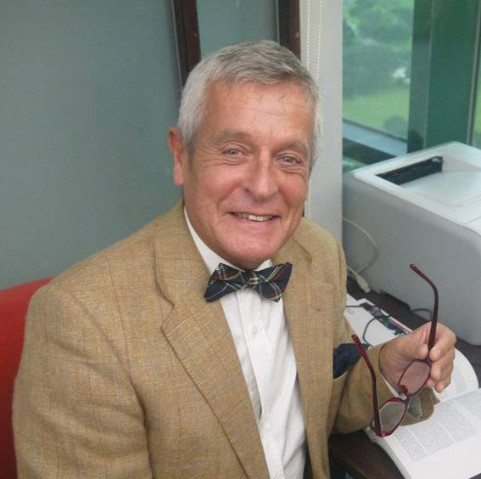 | John Eric Wilkinson
BACKGROUND, QUALIFICATIONS AND EXPERIENCE

Nationality: British
Professional Associate Fellow of the British Psychological Society (AFBPsS)
Affiliation: Chartered Psychologist (C.Psychol)
Fellow of the Royal Society of Arts (FRSA)

Qualifications:
1966 | University of St. Andrews | B.Sc. (Chemistry – 1st class)
1967 | University of St. Andrews | Diploma in Education
1967 | Dundee College of Education | Secondary Teacher's Certificate
1968 | University of Dundee | M.Ed. (Psych./Ed.)
1993 | University of Glasgow | Ph.D.

Experience:
Teacher | Stobswell School, Dundee | 1967-68
Asst. Master | Brockenhurst Sixth-Form College, Hants | 1968-70
Research Associate | School of Education, University of Nottingham | 1970-72
Lecturer | Department of Education, University of Glasgow | 1973-91
Senior Lecturer | Department of Education, University of Glasgow | 1992-98
Acting Head of Department | Department of Education, University of Glasgow | 1994-95
Head of Department | Department of Education, University of Glasgow | 1995-99
Professor of Education | Department of Education, University of Glasgow | 1998-
Vice-Dean | Faculty of Education University of Glasgow | 2001-05

