
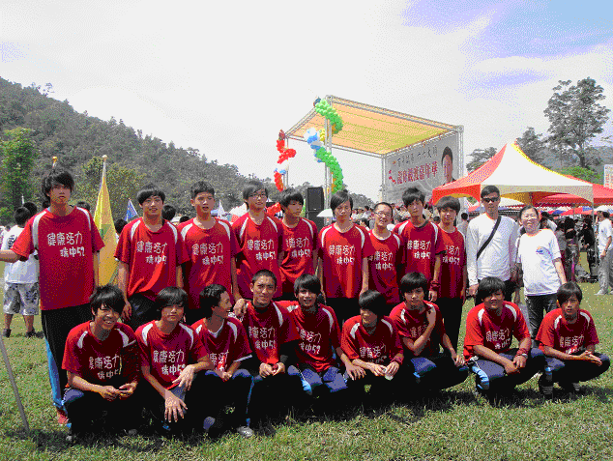
Connecting Classrooms

Cumbria

Open to all pupils in Hualien Primary and Junior High Schools

Take a photo which depicts your viewpoint of Hualien
It could be a scenic view - a lake, a mountain or a coastal spot
It could be a Hualien Festival – Dragon Boats or Harvest Festival
The choice is yours!

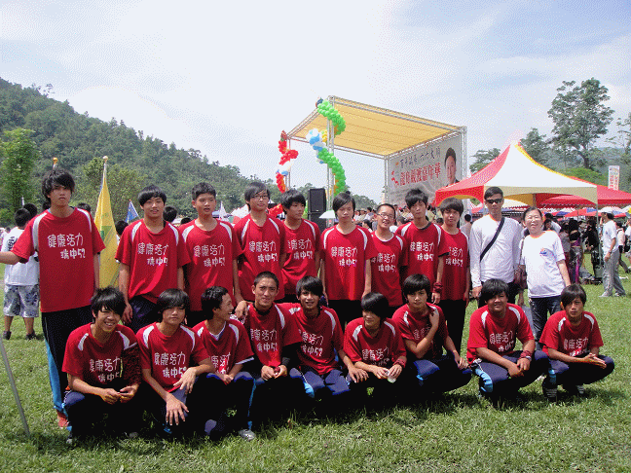

All entries should be emailed in jpg format to:
zcjh056@hlc.edu.tw

Closing date is September 30th 2011

The competition will be judged by from Keith Bales in Cumbria

The winning entry will receive an autographed copy of
Keith Bales’ new book “Cumbria and the Lake District”

