110學年度花蓮縣高中英文造句及寫作比賽題型公告
106.11.18. LT製作
組別 | 高中英文造句組
題型說明與  配分 | 一、造句(sentence making):  A說明(Direction)：  請依照給定自彙或片語造句。造句過程中，請儘量表現參賽者對給定字彙或片語的認識。共10題，每題5分。(Please make complete sentences based on the given words or phrases. Try to demonstrate your understanding of the given words or phrases as possible as you can when you make the sentences. There are 10 questions in this part, 5 points for each question.)  B例題(Example)：  題目：  face the music  在答案紙上寫：After he was caught with the stolen goods, he had to face the music and accept due punishment.  C配分(Evaluation Criteria)：  文法正確度(grammatical correctness): 40%  拼字正確度 (spelling correctness): 20%  切題與創意 (relevancy and creativity): 40%  二、完成句子(complete the sentences):  A說明(Direction):請依照題目句所提示的語意繼續完成句子。共6題，每題5分。(Please complete the following sentences based on the given hints. There are 6 questions in this part, 5 points for each question.)  B例題(Example):  題目句：  Today, many young women do not rush into marriage and motherhood; instead, ____________.  在答案紙上寫：they spend several years establishing careers.  C配分(Evaluation Criteria)：  文法正確度(grammatical correctness): 20%  拼字正確度 (spelling correctness): 20%  切題與創意 (relevancy and creativity): 60%  三、句子接龍(relay writing)：  A說明(Direction)：  請閱讀每題的題目句，再依照推論與創意接龍寫作，一句或多句均可，在文意上不需有任何結論。共4題，每題5分。(Please read the given sentences and relay the writing with at least one sentence. There is no need to draw a conclusion to the given sentences in your writing. There are 4 questions in this part, 5 points for each question.)  B例題(Example)：  題目句：  Hualien County Teenage Orchestra is looking for new players for its 2014 concert performances.  在答案紙上寫：If you are in your teenage and play a wind, brass, or stringed instrument, please come to the orchestra try-outs.  在答案紙上寫：If you are in your teenage and play a wind, brass, or stringed instrument, please come to the orchestra try-outs.  C配分(Evaluation Criteria)：  文法正確度(grammatical correctness): 20%  拼字正確度 (spelling correctness): 20%  切題與創意 (relevancy and creativity): 60%

組別 | 高中英文作文組
題型說明與  配分 | - 故事接龍( story relay):  A 說明(Direction):  請閱讀以下的故事，再依照推論或創意接龍寫作，並完成故事，字數約150~180字（超過不扣分）  B例題(Example):  Just as I was turning to see where the voice came from, I heard the door behind me slam shut! I ran to it and tried to push it open but, of course, it was locked. Now we had to go on; we could not turn back. Chris and Megan called softly to me and I groped my way toward them in the dark. “I think we can still make it if we just stick together and don’’t panic,” Megan cautioned. “Here, let’’s use my belt to keep us together. We can each hold onto part of it as we walk along and even if we can’’t see, we can at least know where…” The belt flew out of my hands as Megan’’s voice fell away beneath us! I fumbled in the dark for a second and then said, “Darn it! Why didn’’t I think of this before?”  C配分(Evaluation Criteria):  文法正確度(grammatical correctness): 30%  拼字正確度 (spelling correctness): 20%  切題(relevancy): 50%  - 看圖寫作(Creative Writing on a Picture):  A說明(Direction):  請根據所給圖片，以第一人稱完成約150-200字有創意的文章。50分。(Please write a creative story to go with the picture in first person from the perspective of the picture.. 50 points.)  B例題(Example):  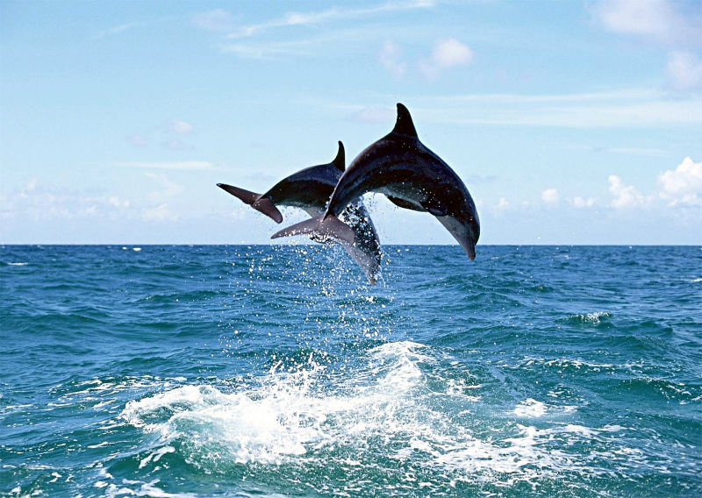  C配分(Evaluation Criteria):  文法正確度(grammatical correctness): 25%  拼字正確度 (spelling correctness): 25%  切題與創意(relevancy and creativity): 25%  組織與表達清晰(organization and clarity): 25%

