「2012年兒童文學國際學術研討會」實施計畫

- 會議名稱：2012 International Conference on Children’s Literature:
The Child in th Book
- 日期/時間：中華民國101年11月16日(星期五)17:00-18:00及
11月17日(星期六) 09:00-18:00
- 活動地點：東吳大學外雙溪校區第一教研大樓
- 主辦單位：東吳大學英文學系
- 指導單位：國家科學委員會、東吳大學、台灣兒童文學研究學會籌備會
- 參加對象：國內外各級學校教師、大專院校學生、從事兒童文學研究相關領
域或對兒童文學研究有興趣者
- 論文發表及討論語言：英語
- 活動簡介：
- 特邀演講(Invited Speech)-
講題：Moving on the way of Children's Publication and Reading in Taiwan ---
Hsin-Yi as an example
講者：Sing-ju Chang (信誼基金會張杏如理事長)
日期：101年11月16日(星期五)
時間：17:00~18:00
*將安排中文同步口譯

- 專題演講(Keynote Speech)-
  - 第一場
講題：When Adults Hold Youth Responsible: Embodiment and Economics
in Children’s and Young Adult Literature
講者：Roberta Seelinger Trites(美國伊利諾大學英文系教授)
日期：101年11月16日(星期五)
時間：09:10~10:10
*將安排中文同步口譯

  - 第二場
講題：Constructed Children as In-between Spaces by Hyphenated
American writers
講者：Junko Yoshida吉田純子(日本神戶女學院大學英文系教授)
時間：13:30~14:30
*將安排中文同步口譯

- 來自於英國、澳洲、加拿大、美國、日本、菲律賓、印度、中國及港澳地區等各地專家學者前來進行學術研究成果之分享：

  - 29場口頭論文：
- Jonas's End of Innocence through his Experience of Sexuality and Death in Lois Lowry's The Giver
- “Wild Kids” (Re)visited: The Narrative of the Juvenile Periphery and the Construction of Juvenile Subjects in Taiwan Juvenile Fiction
- “Slovenly Peter” - Poisonous Pedagogy or a Warning on Overprotectiveness?
- Young Heroic Outlaws: A Portrayal of Child Heroes by Media in Heinberg's Young Avengers
- Suitable for Children? Staging Sex, Death, and Supernatural Horrors at the Balzac Special Exhibition
- Betwixt: Betwixt: Liminal Lives in the Drama “Meteor Garden” Adapted from the Shoujo Manga “Hana Yori Dango
- Impressionism in Chekhov’s Stories for Children
- Fantasy for Adults as a Story of Children : George MacDonald's Lilith
- The Problem with Alice: negotiating the child in the photographs of Lewis Carroll
- Politics of Identity as Rites of Passage in South Asian Diasproic Youth Literature: A Postcolonial Reading of Hidier’s Born Confused and Selvadurai’s Funny Boy
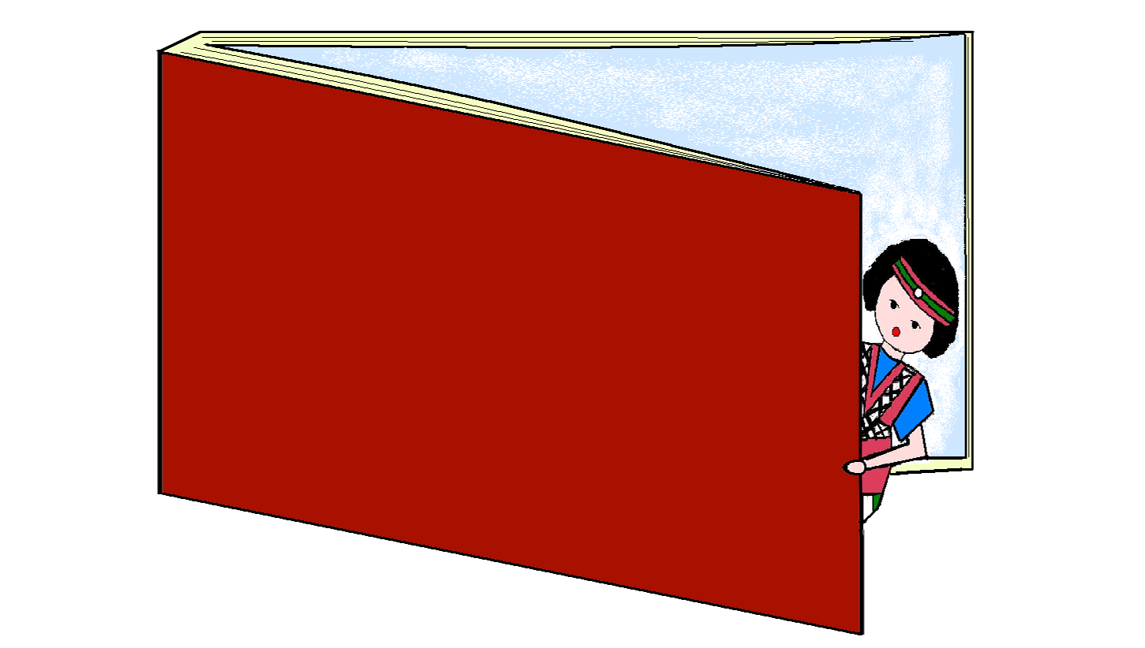
- Hyphenated Humor Trends in the Contemporary Asian-American Child Narrator
- Asia Lost and Found: Two Japanese American Authors of Children's and Young Adult Books
- Children as Writers: Anne Frank
- Curiosity and Orientation: Child as Questioner in Native American Creation Stories
- The Ghost Child in Jayeh's Fantasies for Children
- The Spectrum of Postmodern Children’s Literature: From Innovation to Nostalgia
- “Father of the Man”: Landscaping and Representing the Child in The Secret Garden, The Moon Lady, and Scarecrows and Sparrows
- “Spatial Stories” in Urban Picture Books
- Bhaktaprasad’s Journey of Discovery in Dixit’s Adventures of a Nepali Frog
- Prolegomenon for a Cross-Cultural Study of Anthropomorphism Animals in All of Us – Journeys East and West
- Representation of animalized children- Mowgli of Jungle Books
- “Fighting a good cause”?: Children and War in G. A. Henty's With the Allies to Pekin (1903) and Gerald Milton Wood in Charles Gilson's The Lost Column (1909)
- Children Voices in Wartime
- A Young Suffering Soul: Race, War and Dream in Anne Frank’s Diary
- American Dolls for Japanese Nisei Girls in the 1920s ~ 1940s
- The Girl Who Doesn’t Eat: Connotations of Food and Hunger in Meg Rosoff’s How I Live Now
- Changing Image of the Mother in Japanese YA Literature
- Children's Literature and Modernity: A Case from Ethnic Malay Thai YA Literature
- The Malevolent but Transforming Bond: Dependence and Independence in The Chocolate War and Stargirl

  - 7場壁報論文發表：
- Never, Ever, Break Up a Family
- Examining Cultural Authenticity in Chinese Folktale Picturebooks Written by American Authors: From an Artistic Conception Perspective
- Representations of Transnational Families and Children Coping with Diaspora in Selected Stories for Children by Filipino authors
- Journey to the West as a Children's Text: the Transnational Hero with One Thousand Animal Faces
- Gender-Sensitive Representations of Boys and Girls in Contemporary Japanese Children's Books
- Sleepless in Fairy Tales: Responses of Taiwanese School-Aged Children to the Variants of “Little Red Riding Hood” as Bedtime Stories
- Representations of Diversity: Cinderella Stories from Around the World

- 會外活動：
  - 童謠演奏：東吳大學音樂系四重奏
  - 傳統童玩藝術表演：
      - 大安國小扯鈴表演
      - 西門國小跳繩表演
      - 蘭雅國小撥拉棒表演
      - 士敏國小布袋戲表演
      - 米倉國小陀螺表演
  - 書展：
      - 信誼基金出版社
      - 文鶴出版有限公司
      - 台灣東華書局股份有限公司
      - 文景書局有限公司
      - 風車圖書出版有限公司

- 議程表：如附件

- 研習時數申請：
- 101年11月16日(星期五)：1小時
- 101年11月17日(星期六)：9小時

